Summary findings:

**Animals:** There are more dogs than cats at the shelter.

**VOLUME:**

**Busiest Intake times:**

* Months – July, December, August
* Time of Day: Late afternoon / Evenings 4-6 with 5 being peak

**Slowest Adoption Times**

* Months – April, March, May
* Time of Day: During working hours the early mornings are slowest.

**Busiest Adoption times:**

* Months – July, December, August
* Time of Day: Late afternoon / Evenings 4-6 with 5 being peak

**Slowest Adoption Times**

* Months – April, March, May
* Time of Day: During working hours the early mornings are slowest.

**STAFFING: Incoming Flow:**

* Most Staffing Needed: June - December
* Slowest Staffing Time: Jan - April

**Intake Demographics:**

* Age Upon Intake: Most common years at Intake: 1 year, 2 year, 1 month
* Top 2 Intake Reason:
  + Strays = 73%
  + Owner Surrender = 21%
    - Out of the Owner Surrender 88.3% have an intake listing Normal Condition

**Outcome Demographics:**

* Age Upon Outcome: Most common years at Outcomes: 1 year, 2 years, 2 months.
* Top 2 Outcomes
  + Adoption 46.6%
  + Transfers 30.4%
* Adoption Count by Year:



* Euthanasia Count by Year



* What is the most common subtype for Euthanasia?

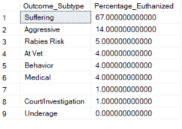

* Subtype that Died without Euthanasia

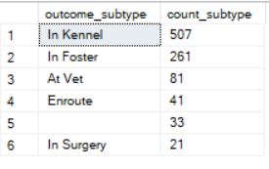

* Subtype that Died without Euthanasia by Year

Year Count Reasons for “Died”

2013 1

2013 8 In Foster

2013 13 In Kennel

2013 1 In Surgery

2014 16

2014 4 At Vet

2014 6 Enroute

2014 36 In Foster

2014 38 In Kennel

2014 2 In Surgery

2015 6

2015 5 At Vet

2015 5 Enroute

2015 31 In Foster

2015 97 In Kennel

2015 2 In Surgery

2016 1

2016 10 At Vet

2016 2 Enroute

2016 40 In Foster

2016 86 In Kennel

2016 5 In Surgery

2017 1

2017 12 At Vet

2017 5 Enroute

2017 41 In Foster

2017 58 In Kennel

2017 5 In Surgery

2018 18 At Vet

2018 9 Enroute

2018 30 In Foster

2018 74 In Kennel

2018 2 In Surgery

2019 7

2019 26 At Vet

2019 7 Enroute

2019 46 In Foster

2019 97 In Kennel

2019 4 In Surgery

2020 1

2020 6 At Vet

2020 7 Enroute

2020 28 In Foster

2020 42 In Kennel

2021 1 In Foster

2021 2 In Kennel

**Animal Demographics:**

**Dogs:**

* **Top Dogs Breeds:**

Top Intake Dog Breed: Pitbull Mix, Labrador Retriever Mix, Chihuahua Shorthair mix

Top Adopted Breed: Labrador Retriever Mix, Pitbull Mix, Chihuahua Mix

Top Euthanized Breed: Pitbull, Chihuahua Mix, Labrador Retriever Mix

* **Top Dog Color:**

* Intakes

Tricolor

White/Liver

Sable/White

* Adopted

Black/White = 4236

Brown/White = 1880

Tan/White = 1869

* Euthanized

Black/White - 166

Brown/White - 113

Tan/White 107

* **Top Dog Names:**

Max = 537

Bella = 474

Luna = 414

Rocky = 374

Daisy = 365

Charlie = 317

Coco = 307

Buddy = 305

Princess = 299

Lucy = 287

* **SubType for Dogs Dying without Euthanasia:**

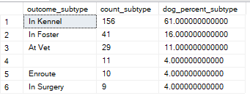

**Cats:**

* **Top Cat Breed: (There are not many cat breeds)**

Top Intake Cat Breed: Domestic Shorthair Mix, Domestic Shorthair, Domestic Med Hair Mix

Top Adopted Cat Breed: Domestic Shorthair Mix, Domestic Shorthair, Domestic Med Hair Mix

Top Euthanized Breed: Domestic Shorthair Mix, Domestic Shorthair, Domestic Med Hair Mix

* **Top Cat Color:**

* Intakes

Calico

Cream Tabby

Black/White

* Adopted

Brown Tabby

Black

Black/White

* Euthanized

Brown Tabby

Black

Black/White

* **Top 10 Cat Names**

Luna = 124

Charlie = 121

Lucy = 86

Max = 84

Bella = 84

Oliver = 83

Lily = 82

Shadow = 79

Jack = 79

Daisy = 74

* **SubType for Cats Dying without Euthanasia:**

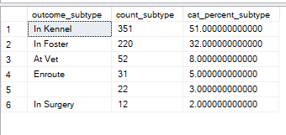

@E$bRpXy*gWba3$@Tn